Playstation Network Required Ports
TCP 80
TCP 443
TCP 5223
UDP 3478
UDP 3479
UDP 3658
Remote Play & Gaming Required Ports
TCP 80
TCP 443
TCP 5223
TCP 9293
TCP 10070-10080
UDP 3478
UDP 3479
UDP 3658
UDP 10070

Tweak Tversity

What you will find here is the result of scouring countless forums, trial and error, and good old fashion common sense. The goal here is not to take credit for discovering the optimal settings for streaming media with TVersity, but to get everything down one place, written in a clean, concise fashion.
Step 1: Clean Out Your Codecs (skip this section if you have no problems)
The number one reason people have problems with TVersity is that the codecs installed on their system are not in order. The majority of “Unsupported Format” and “Corrupt Data” errors are the result of missing or invalid codecs.
The first thing to do is to get rid of all the disparate codecs installed on your system. This includes stand-alone Xvid, etc. codecs as well as installs you may not suspect such as Nero Premium and tools like AVI Splitter.
A good test to see if your system is clean is to try and play a Xvid or x264 file from Media Player Classic or VLC and it not playing. If the video renders there’s a codec still installed on your PC and you need to track it down and uninstall it.
Step 2: Install TVersity and the codec pack included with Tveristy
The current version of TVersity is 0.9.11.4. TVersity is very much a work in progress. It can crash or stop working at times but for that most part it’s the best tool out there for streaming media to the PS3.
TVersity consists of two components: The media server itself (which is invisible to the user) and the Flash front-end. The front-end does not need to be running for Tversity to operate. The media server runs as a system service.
If you use network shares you need to configure the service to run under an account that has access to the shares.
Go to the Windows Services applet (from the Run… menu type “services.msc”) and in the list find the “TVersityMediaServer” service. Double-click on it and go to the “Log On” tab and change the process to run under your Windows account.
If the service is not already started, start it. Also insure the Startup Type is set to “Automatic”.
At this point TVersity should be operational. I am not going to go into how to add your media to the server as that’s beyond the scope of this guide and it should be fairly straight forward.

Step 3: Optimize the Transcoder
The goal here is to optimize the transcoder to output the best possible video quality possible. Keep in mind that this involves a great deal of horsepower and network bandwidth. I am transcoding on a 3.0Ghz P4 Dual Core over wired network and have yet to hit my head on the ceiling with these settings. Your mileage may vary and if it does you will need to scale back where appropriate, especially if dealing with HD content.
Start up the TVersity front-end and navigate to the Settings->Transcoder tab.
When To Transcode?
This should default to “Only when needed” so keep it there. This will allow TVersity to pass-through MPEG and AVS formats without transcoding overhead and image degradation.
Maximum Video and Image Resolution
This determines how the transcoder will scale (down) your media in order to conserve network bandwidth. We want the best image possible so set both of these fields to the maximum resolution of your television. I have a 1080p native set so I set it to 1920×1080. If you’re at 720p set it to 1280×720. The “Image resolution” boxes pertain to photos, it does not hurt to crank them all the way up as well.
Windows Media Encoder
TVersity uses DirectShow under the hood to do the actual media transcoding.
Make sure the “Use DirectShow…” checkbox is checked and that the Windows Media Video version is set to “9″. You can choose an older version of Windows Media for faster decoding but 9 produces the best image quality (at least on paper).
Optimization
This is a no-brainer. Tag it for quality.
Connection Speed and Quality
Here’s where things can get sticky. If on a 802.11g connection in a small apartment and have no problems set the connection type to “Wired” and the signal strength to “Excellent”. If you notice network stuttering or dropouts definitely scale these settings back.
In my experience the PS3 does a thorough job in buffering content. As long as your PC can encode at a pretty decent rate (2x or greater) the connection settings don’t mean much as the PS3 will buffer way ahead of what is being played, assuming your network can keep up.

Compression
By transcoding we’re essentially re-compressing and already compressed file. This equates to a degradation of image quality. Set compression to “Minimum”. This is going to result in a larger file being sent over the network, but it results in better image quality at playback.
Decoding Speed
Finally, ensure the “Decode the media as fast as possible…” box is checked. The PS3 times out pretty quickly if the media does not load fast enough and this setting helps with that.
Step 4: Optional Tweak
Output to MPEG2
In the TVersity install folder (C:\Program Files\TVersity\Media Server) find and edit the file “profiles.xml”. Ensure you are in the “Sony Playstation 3″ profile block, there should be a block of code that looks like:
<!-- When transcoding is needed to which format should we transcode -->
<transcodeTarget
audio="audio/x-wav"
video="video/mpeg16"
photo="image/jpeg"
onlineAudio="audio/mpeg"
onlineVideo="video/mpeg16"
onlinePhoto="image/jpeg"
adjustReadStartPos="false"
audioFailFutureSeek="false"
videoFailFutureSeek="true" />
Change it to read:
<!-- When transcoding is needed to which format should we transcode -->
<transcodeTarget
audio="audio/x-wav"
video="video/mpeg2”
photo=”image/jpeg”
onlineAudio=”audio/mpeg”
onlineVideo=”video/mpeg2”
onlinePhoto=”image/jpeg”
adjustReadStartPos=”false”
audioFailFutureSeek=”false”
videoFailFutureSeek=”true” />
This will ensure the transcoder produces MPEG2 video as opposed to MPEG1, which results in overall better looking video. You will need to restart the media sharing service from the TVersity front-end after making this particular change.

If you're using ffdshow as codec, go into 'Resize & aspect' in ffdshow configuration, check 'Resize', pick 'Specify horizontal size' and enter '1280'.
This will upscale every movie to be 720p, and you'll get MUCH better quality on PS3.
Of course you'll need more CPU power to transcode 1280x720 movie.
Conclusion
You should now be able to playback nearly any video file you throw at your PS3 in high-quality. Granted, I’ve come across one or two files that refused to play (mainly video podcasts or Flash video) but for the most part I’ve been enjoying high-quality steaming media using TVersity and the PS3.
If you encounter any problems be sure to check the TVersity Support Forums, the PS3 Forum in particular.

MKV

Posted: Sat Nov 17, 2007 10:23 pm Post subject: -Guide- Playback with Embedded and External Subs
A little guide to help you get setup with subtitle support with your videos. Embedded subs in MKVs have always been the most troublesome to get working, you should be able to run them with this guide.
Note: Take a look at your videos /w embedded subs using MediaInfo (http://mediainfo.sourceforge.net/en) check what the subtitle source is. SRT embedded videos don't work for me, but UTF does. Other than the SSA/ASS/ASS2 subs that are configured in ffdshow, not sure what other types are supported besides UTF.
with the new version I'd suggest changing the Media Library to "File System" setting. Makes organization much easier.
PS3 2.10
TVersity 0.9.11.4
XP Pro
Before you start please remove all codecs.
----Method A---- simple steps .MP4 extensions were the only files I could not transcode, but they should work without transcoding. I'll have more info if Alui finds some that the PS3 won't play.
1. Download latest ffdshow
http://www.free-codecs.com/download/FFDShow.htm
2. Download gabest matroska filter (thanks Davin, I could never find the standalone version)
http://sourceforge.net/project/showfiles.php?group_id=82303&package_id=84361&release_id=400404
There are 2 versions of the matroskasplitter.ax (use Release Unicode for NT versions of Windows...2000/XP)
Copy the file into your C:\Windows\System32 directory
Register the codec manually.
-start > run > cmd
-type cd c:\windows\system32
-type regsvr32 matroskasplitter.ax
Edit ffdshow video decoder settings
Scroll down to the Subtitles section and check it.
Make sure to check on:
-Accept embedded subtitles
-Accept SSA, ASS and ASS2..
-Decode closed captions
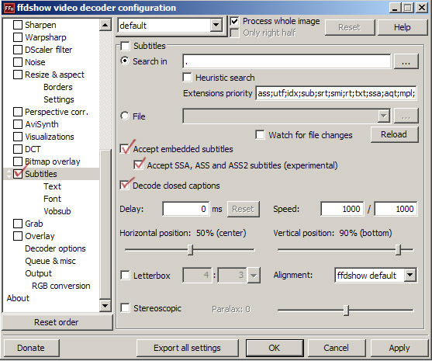
----Method B---- more complete but more configuration needed
Only codec pack you'll need is the K-lite FULL version codec pack. So before you start remove all your codecs.
http://www.free-codecs.com/K_Lite_Codec_Pack_download.htm
Installing the codec pack
Gotta pay attention to what filters you select when you install, you can change it later with the codec tweak tool if you make a mistake though. The reason MKV's with embedded subs give you difficulty is that pretty much all codec packs default to the Haali matroska filter and don't even give you a choice for Gabest. Never got subs working with the Haali filter.
-make sure you select ffdshow for H264 instead of CoreAVC
-make sure you select the Gabest filter for MP4, MKV and OGG instead of the Haali version.
-make sure you uncheck DirectShow subtitles filter so ffdshow can do this.
-also ffdshow should be selected for any filter type that you want to run external subs from like xvid/divx.
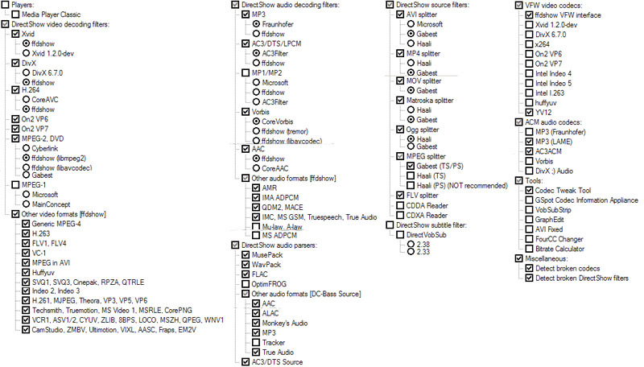
If you notice any problems with subs, open the codec tweak tool and make sure to disable any filter that Haali is using.
Edit ffdshow video decoder settings
Scroll down to the Subtitles section and check it.
Make sure to check on:
-Accept embedded subtitles
-Accept SSA, ASS and ASS2..
-Decode closed captions
---------------------------------------------------------------------------------------------
(Still need to do the following for both methods)
-TVersity settings-
General settings you want the PS3 as the selected media device.
Transcoder settings always want transcoding on. The rest of the settings you're free to tweak as you like.
I use 1280x720 res, optimize Quality, Wired, and Minimum compression.
You'll probably want to change the transcoding to mpeg2 as well, open the profiles.xml in notepad and Ctrl+F to search "playstation". Scroll down a bit further and you'll see the transcoding settings. Change the video and onlineVideo from mpeg16 to mpeg2.
Quote:
<transcodeTarget audio="audio/x-wav" video="video/mpeg2" photo="image/jpeg"
onlineAudio="audio/mpeg" onlineVideo="video/mpeg2" onlinePhoto="image/jpeg"
adjustReadStartPos="false" audioFailFutureSeek="false" videoFailFutureSeek="true" />
If you have windows firewall on, you need to make an exception for the mediaserver.exe
Start > control panel > windows firewall settings/security settings > Exceptions tab > add program > search your tversity directory for mediaserver.exe
**Important don't skip this**
Change the login for tversity service.
Right click my computer > manage > services & applications > services
find "TVersityMediaServer" and double click to open properties
click on "Log On" tab and change the login from the local system account to an account for the computer. (your account must be password protected or windows will not accept it)
Custom Menu
Start med at vælge Custom i settings. Save. Stop Tversity servicen og luk Gui.
Derefter skal du editere config.xml filen. Find den entry der hedder <index parent="TVersity Custom.Folders" props="folder"></index> og ændre den til <index parent="TVersity Custom" props="folder"></index>. Gem filen.
Start TVersity. Når du opretter en folder, så gør du som du plejer med hensyn til Folder og Title.
Det nye er i Menu. Der skriver du hvad menu punktet skal hedde f. eks. ".Movies" - husk punktummet. Hvis du ikke bruger punktum, så kommer subdirs ikke med. Anførselstegn skal ikke med.
Når du opretter en audio url, så gør du som du plejer i Folder og Title. I Menu skriver du hvad menupunktet skal hedde f. eks. "Radio". Du skal IKKE bruge punktum her.

INSTALLATION (*CRITICAL*)
-------------------------
1) Install your codec pack after a *cleaning* of your previous codecs, if any
2) Reboot after installing the codec pack
3) IMPORTANT: FFDSHOW must be set to decode the proper video types. This is very simple. If you have installed the Vista Pack, go to your start menu, find the Vista Codec Pack, under 32bit Tools, select Video Decoder. The process is the same w/K-Lite, but it will probably have a different folder name and instead will be called "FFDSHOW". Its the same file. You will see a list of selections on the left of FFDSHOW, select "Codecs". On the right, you will see a list with three columns: Format, Decoder & Supported FOURCCs/Remarks. Under the "Decoder" column, make sure that the *only* ones listed as "Disabled" are WMVP, MSS1/2, DV, Other DV, Chinese AVS, Fraps, AVISynth & Raw Video. You will most likely not need these and they can cause issues.
With the exception of WMV file types, you can safely select "libavcodec" as the Decoder. Under WMV, I suggest WMV9 or WMV 8. WMV9 will be the most compatible.
Congrats. You can now play just about any video.
You do not need to do anything to use the Haali splitter, which will make any H264 / HD /MKV pretty much a non-issue. There are some odd variations of MKV out there, but I have yet to have an issue with any.
4) REBOOT. This will allow the codec changes to be saved correctly & load when needed. This is basically for a registry refresh.
5) Install Tversity. *DO NOT INSTALL THE INCLUDED CODEC PACK*
6) Reboot.
7) Open System Services, easiest way is to just hit the windows key+R (the run command) and type: services.msc. *STOP* The Tversity Media Server service.
Right click the Tversity service, select Properties. Make sure the Startup Type is "Automatic". Click the "Log On" tab at the top. Under "Log On As:" select "This Account". Click Browse on the right-hand side. On the pop-up window, click Advanced. On the 2nd pop-up, click Find Now. At the bottom under Search Results and Name(RDN) you'll see a few selections. One will be the User Name you use on your windows logon. Double click this. This will bring back the 1st pop-up window. Click ok. Under "This Account" you should now see your user name. Clear the Password field and enter your Windows password, do the same under Confirm Password.
***note: alternatively (I suggest this if you can manage it) you can create a 2nd user account, and use this name as the logon for the Media Server. This has many advantages, but don't worry about it if you can't figure it out.
*THIS MUST BE DONE BEFORE THE NEXT STEP* in order for the profile to be correctly updated & loaded.
Find this file:
c:\Program Files\TVersity\Media Server\profiles.xml Copy it and save the copy in a safe location.
Right click on profiles.xml and select open. When windows asks what program to use, just select Notepad or Wordpad, whatever you want.
Once the file opens, search for "Playstation3"
Find the 2 places under this profile that say MPEG16 and change it to say MPEG2. Save the file. This will ensure MPEG compatibility. Let me know if you have questions on this, but you've probably already done this if you have been messing w/Tversity for a while
9) REBOOT. Don't be lazy and skip this and then complain it didn't work.
10) ONLY AFTER YOU HAVE COMPLETED #8 AND REBOOTED SHOULD YOU START THE TVERSITY PROGRAM FOR THE FIRST TIME. Open Tversity. Click Transcoder. Copy the below settings to ensure smooth playback:
When to Transcode?
Always. Check "Decrease the bitrate if it is too high for my network". If its too high, it won't play back right anyway.
**CRITICAL**: Maximum Video and Image Resolution
NOTE: After much fuss, I found this seems to be the one thing that screws it up for everyone. Don't be POSH and think you have to have full HD. Unless you have a lightning fast *ethernet* connected network and a dual-Xeon processor and a crap-ton of ram, 1280x720 on-the-fly transcoding just is not gonna happen for *all* of your video. It MAY work for some, but your high-end MKV stuff just probably won't work. Don't fret though, cuz it doesn't matter. I suggest trying 720x405 or another multiple/factor of 1280x720 that comes out to the same ratio, or when divided equals 0.5625 (i.e. 405 div by 720=0.5625, so does 720 by 1280, etc).
Either way, it looks the same on my Samsung 42in plasma, and I'm a huge nut on quality.
Windows Media Encoding
Check "Use Directshow....." (this will allow the FFDSHOW codecs you installed to work correctly)
You can select whatever on the drop down, but I've found selecting Windows Media 8 or 9 works best.
Optimization
Select quality. If you have huge playback issues, do not assume selecting speed will help. If you experience stuttering, its most likely still the resolution.
Connection speed. Set this closest to your actual network speed. **CRITICAL**: Setting this higher than your network's bandwidth may affect the packet size and bitrate sent across your network, resulting in failures, disconnects, DLNA errors & stuttering playback.
Compression: Minimum. Anything else will make your video look like crap, even if it still stutters.
Decoding Speed: Check the box. This will allow a variable bitrate when needed and again help decrease stuttering and drop-outs.
**CRITICAL: DON'T FORGET TO CLICK "SAVE" AT THE BOTTOM, ROOKIE
**CRITICAL: CLICK GENERAL ON THE LEFT, AND RESTART SHARING. THIS WILL REFRESH YOUR NEW SETTINGS.
**CRITICAL: I can't lead you thru every step for every router, but I can tell you it is CRITICAL you us "Port Forwarding" (and NOT port triggering; too complicated & unnecessary) and add Port 41952 to your router, if you use one, which you should if you want this to work worth a crap. CRITICAL: The IP address that is associated w/port 41952 should be the IP ASSIGNED TO YOUR PC BY YOUR ROUTER.
**edit: clarification: ip address** The IP address (if you use it) *in Tversity under "General"* should be your PS3's IP. If you don't know what I'm talking about, leave it blank and move on with life.
The IP address *your router will need* when you *forward port 41952* should be your PC's IP. This is to tell the router its okay for your PC to send traffic on this port. Do not assign your PS3's IP or you will just cause traffic jams, which ultimately result in collisions, and road blocks. Ok to many street analogies. If you don't know your ip do this:
Use your "Run" command in windows or hit the Win Key+R, then in the Run field type CMD. This will pull up a DOS window. In the DOS window type: ipconfig. Hit enter. The screen will fill with all kinds of crap. Scroll up until you see something like this:
Wirless LAN adapter Wireless Network Connection:
Under this line you will see some numbers & letters; gibberish. One line says "IPv4 Address..........192.168.1.x" This IP should be assigned w/port 41952 forwarded. This is your PC's IP address.
**CRITICAL** You must also make sure the UPnP is enabled in your router. This allows PS3 to make it self "available" as a media server connection. Keep in mind, some sharing may still work without this, but it will inevitably cause errors with some files, etc.
Once you have set up your router correctly, this should work fine for you. After much troubleshooting, config.xml editing (don't bother) and profile.xml tweaking (don't bother with the exception of the above mpeg16/mpeg2 tweak), I have found the #1 thing that has caused compatiblity is the RESOLUTION. The 2nd thing is correctly setting up the Tversity service (services.msc) and the other is the port forward.

For those with distorted sound with MKV playback, make sure FFDShow audio decoder is *not* set to decode AC3 or PCM.
Pull up AC3Filter and make sure these audio types *are* checked to be played with AC3Filter.

Earlier I suggested for HD to use a resolution such as 1080x608. 1080 is evenly divisible by 8, 608 by 16, so this works.

